Team roles:

Frontend: Chaoya Ji & Shuo Ma

Backend: Ke Peng & Kan Zheng

Database: Guangshuai Zhang & Min Yu

Meeting: Every Thursday noon at Evans

Link to frontend design: (Low-fi UI)

<https://moqups.com/pk490625936@gmail.com/v85EhWYS/>

Pivottracker:

https://www.pivotaltracker.com/n/projects/1565533

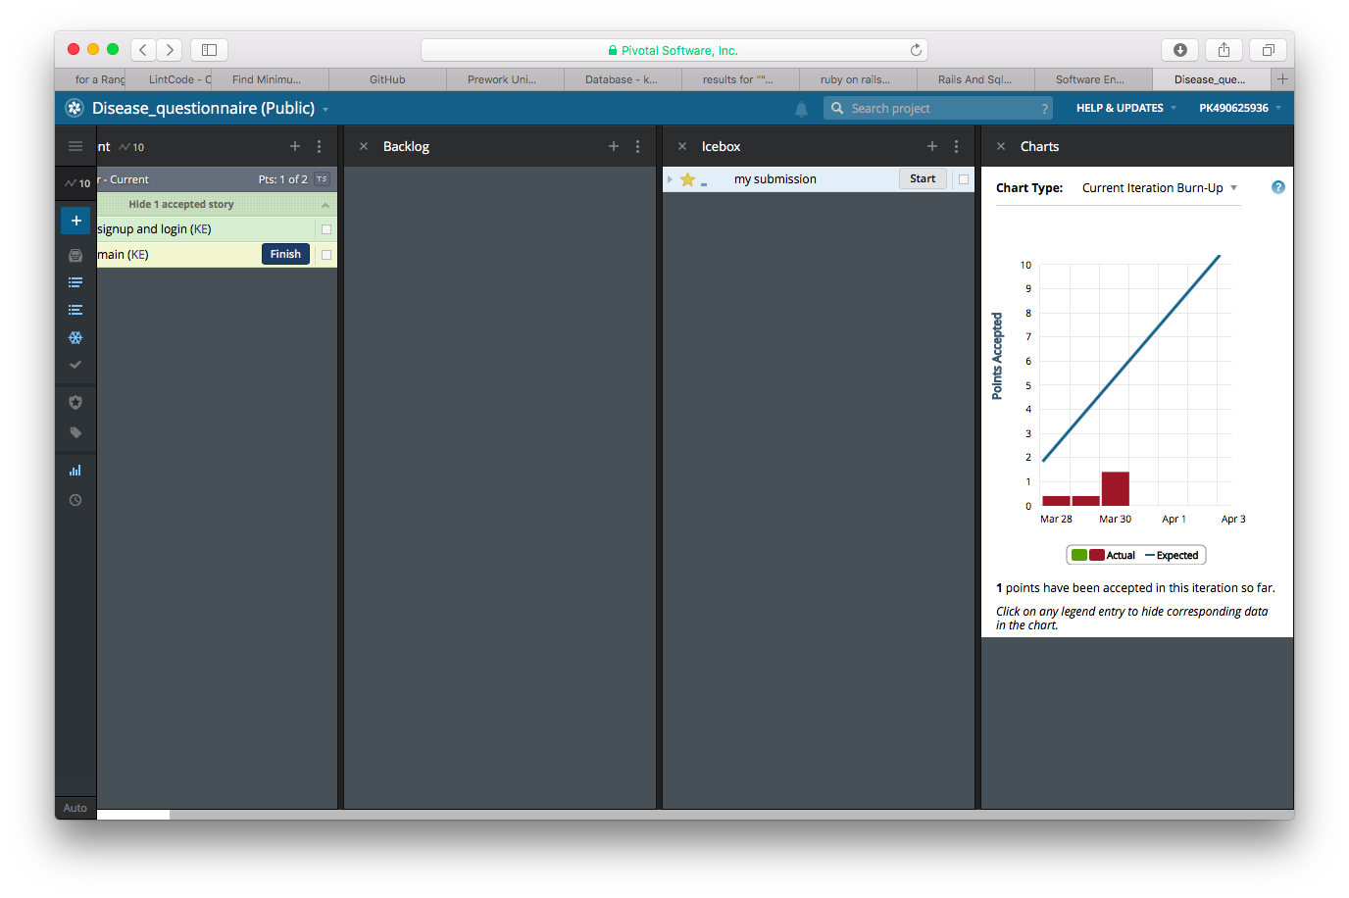

Github

<https://github.com/marshalma/DiseaseDatasetCuration>

User storey

Feature: Add a register, login, submission, mysubmission and Administrator page

As a user or admin to the dataset website

So that I can register and login to the dataset website

I want to register and login to the dataset website, do the questionnaire, and check what I have done. If I am a admin, I can check all the user’s submission and closed the questionnaire which meet the close requirement

Video:

[www.youtube.com/watch?v=t336OP8dBX0](http://www.youtube.com/watch?v=t336OP8dBX0)

(The first man is the customer who introduces the problem, the second man is the representative of our team to introduce how to do the product.)

Summary: Finish iteration 0 and customer is satisfied with the design of frontend.

The project is to build a questionnaire. First we have a user register and login, then we have a main page which shows the questionnaire, then for each user, he can see what answer he submit. At last, a super user can get the overview info of the answer all people do.